Japanese Pitch accent Trainer
Design Document

Hafza Abdullahi
4th year Software Dev Student
submission date: 13/02/2026

Contents
SYSTEM ARCHITECTURE OVERVIEW 3
Presentation layer (client) 3
Application Layer (Python + Render) 3
Render Workflow 4
Google SPEECH API VALIDATION 7
Overview of system 8
Data Layer (Firebase + Local JSON Assets) 9
anki connect api 9
USER INTERFACE ARCHITECTURE 9
Widget Hierarchy 9
UI screenshots 10
References 11
Software and libraries used 11
Links 12

SYSTEM ARCHITECTURE OVERVIEW
The Japanese Pitch Accent trainer is built using Flutter and Python. Comprising of both a mobile app and web.
The system is made up of three primary layers
- Presentation Layer (Client): A Flutter based application handling the user interaction, audio recording, and visual feedback display.
- Application Layer (Server): A Python Flask API hosted on Render, responsible for pitch extraction and graph generation using Praat-based algorithms.
- Data Layer: Firebase for authentication and cloud storage, combined with local asset management for Anki deck integration.

Presentation layer (client)

Responsible for
- User authentication
- Audio recording and playback
- Flashcard rendering
- Graph visualization from backend responses
Flutter compiles to both Web and Android, a single codebase maintains consistent behaviour across platforms.

Application Layer (Python + Render)

This layer performs all digital Signal Processing tasks that would be too heavy for mobile browsers on Render.
Render[1] is a modern cloud hosting platform that lets you deploy web apps, APIs, databases, and background workers without managing your own servers. The python render server handles:
- Pitch extraction
- Contour smoothing
- Graph generation
Parselmouth (Praat for Python) allows industry standard acoustic analysis without implementing raw DSP manually.
Why is Render used?
This project uses Parselmouth, SciPy, Matplotlib, and other low-level audio libraries. These require:
- system-level dependencies (like libsndfile1)
- Linux audio libraries
- a controlled environment
Render supports Docker, meaning you can ship your entire backend (all Python + C++ library requirements) inside a pre-built container.
This guarantees it runs the same way on the cloud as it does on your local machine.
Other platforms (like Firebase Hosting or Vercel) cannot run Parselmouth because they don’t support such heavy DSP libraries. So, Render was the best option

Render Workflow

1) User action (client)
- User taps the microphone button or drops/imports an audio file.
- Flutter records audio:
  - Web outputs .webm
  - Mobile outputs AAC/other formats depending on implementation
2) Upload to backend (client to Render)
- Flutter sends an HTTP request to:
  - POST /process-audio
3) Server receives and stores upload (Render)
- Flask verifies audio exists in request.files.
- The file is written to a temporary file on disk using tempfile.NamedTemporaryFile(delete=False) so Parselmouth can access it by path.
4) Convert audio to WAV (FFmpeg via Pydub)
Pitch extraction and speech recognition require a consistent format.
- The backend attempts:
  - AudioSegment.from_file(temp_webm)
  - audio.export(temp_wav, format="wav")
If conversion fails (edge case handling):
- If file size is non-zero, the server attempts to use the raw file directly.
- Otherwise, it throws an error
5) Speech transcription (Google Speech Recognition)
- The server loads WAV using SpeechRecognition.AudioFile
- It calls:
  - recognize_google(..., language="ja-JP")
Possible outcomes:
- Success → returns Japanese transcription (kanji/kana depending on recognition)
- UnknownValueError → "Could not understand audio"
- RequestError → "API Error: ..."
6) Romaji conversion (pykakasi)
- The transcription is converted to Hepburn romaji:
  - romaji = " ".join([item['hepburn'] for item in result])
This gives learners a readable fallback even if they can’t yet read the kanji.
7) Pitch extraction + graph generation (Parselmouth + Matplotlib)
- Parselmouth loads the WAV:
  - snd = parselmouth.Sound(audio_path)
- Extract pitch contour:
  - pitch = snd.to_pitch()
  - times = pitch.xs()
  - frequencies = pitch.selected_array["frequency"]
Graph output:
- Matplotlib generates a plot of frequency (Hz) over time (s)
- Title includes combined transcription label:
  - "{romaji} : {transcription}"
Smoothing:
- The file includes placeholders for smoothing approaches:
  - moving average, gaussian, savgol
- Currently the server plots the raw contour (and a lightly duplicated plot line); smoothing can be enabled later if desired.
8) Response packaging (PNG + headers)
- The plot is saved to memory (io.BytesIO()) as a PNG:
  - plt.savefig(img_buffer, format="png", dpi=150)
- Flask sends:
  - PNG bytes as the response body (send_file(..., mimetype="image/png"))
Transcription is returned via headers:
- X-Transcription contains URL-encoded Japanese text
- X-Transcription-Romaji contains URL-encoded romaji
URL encoding is necessary because headers may break with raw non-ASCII characters.
9) Client receives response and updates UI
Flutter:
- Decodes PNG bytes → shows pitch contour image
- Reads headers → displays transcription + romaji
- Updates the flashcard UI to show:
  - pitch graph
  - transcribed text
  - (optional) comparison against expected card reading (future feature)
10) Cleanup
Server deletes temporary files in finally:
- temp webm
- temp wav
This avoids leaking storage and keeps the container stateless.

Google SPEECH API VALIDATION
In addition to the graphs, the system uses speech recognition as a first step validation system. It returns what word it heard the user say.
Educational Benefit
This speech validation layer provides:
- Immediate feedback if the wrong word is spoken
- Reinforcement of vocabulary recall
- Prevention of “graph-only” focus
- Integration of pronunciation + lexical accuracy
Without this layer, a user could produce correct pitch contour on the wrong word.

Limitations of Speech API Validation
While effective, speech recognition is problematic as it could:
- Misrecognize clear speech
- Return homophones (橋 vs 箸 vs 端) all written as “hashi”
- Fail in noisy environments
- Return kana when flashcard uses kanji

Dynamic Time warping

Pitch contours extracted from real speech varies due to:
- speaking speed (fast/slow)
- micro pitch fluctuations
- timing differences between morae (syllables)
- recording latency and trimming differences

Dynamic Time Warping (DTW) solves this by aligning two time series that may differ in length or timing, producing a similarity score based on the best possible alignment
This allows the system to:
- compare a learner’s pitch contour to a reference contour properly
- differentiate homophones that differ primarily by pitch pattern
- provide a meaningful score even when timing differs

Overview of system
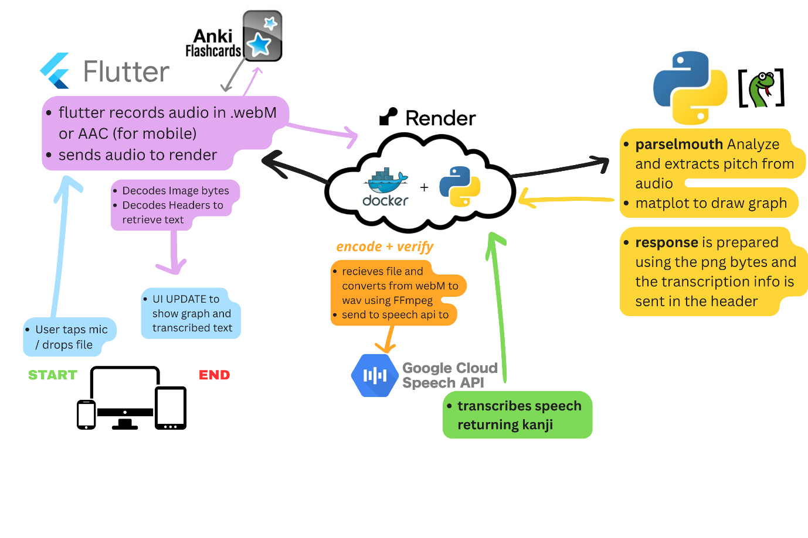

Data Layer (Firebase + Local JSON Assets)

The project integrates two data sources:
- Firebase Authentication: Manages secure user sessions.
- Local JSON Decks: Pre-processed Anki flashcards containing vocabulary, readings, example sentences, and audio assets.

anki connect api

To integrate vocabulary from the a deck into flutter, the project uses AnkiConnect[2], a local REST API plugin that exposes the user’s Anki data (notes, fields, and media files including audio) through HTTP requests. This retrieves the card info from a premade flashcard deck “Kaishi 1.5k - Basic Japanese Vocabulary[3]“

Since Flutter Web and mobile apps cannot directly read .apkg deck files (due to SQLite parsing limitations and browser sandboxes), I used preprocessing script in Dart to extract all relevant flashcard information before packaging the app, later this will be reworked so the deck is uploaded to the firebase database.

USER INTERFACE ARCHITECTURE

Widget Hierarchy
The UI is decomposed into modular, testable widgets, each following the Single Responsibility Principle:
- WelcomeScreen
Determines navigation flow based on authentication state.
- LoginScreen
Implements Google Sign-In using FirebaseAuth, (currently not implemented)
- HomeScreen
Displays flashcards, handles recording, transmits audio to the backend, and renders pitch graphs.
  - Displays flashcards
  - Handles recording or file upload
  - Transmits audio to the backend
  - Receives pitch graph + transcription
  - Renders the results inline

- WordCard Widget
Presents:
  - Kanji
  - Furigana
  - English meaning
  - Example sentence
  - Native speaker audio button
This mirrors standard Japanese learning tools (e.g., Anki), maintaining user familiarity

UI screenshots
App flashcard format as presented to the user before audio has been uploaded
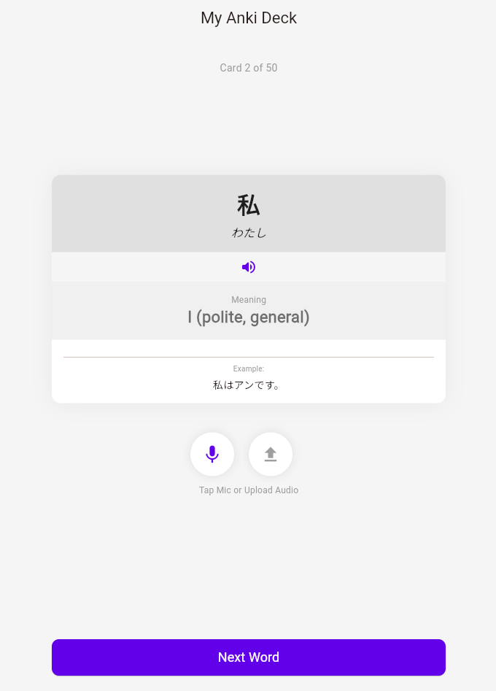
App flashcard after using has uploaded audio from a file and pressed analyse pitch.
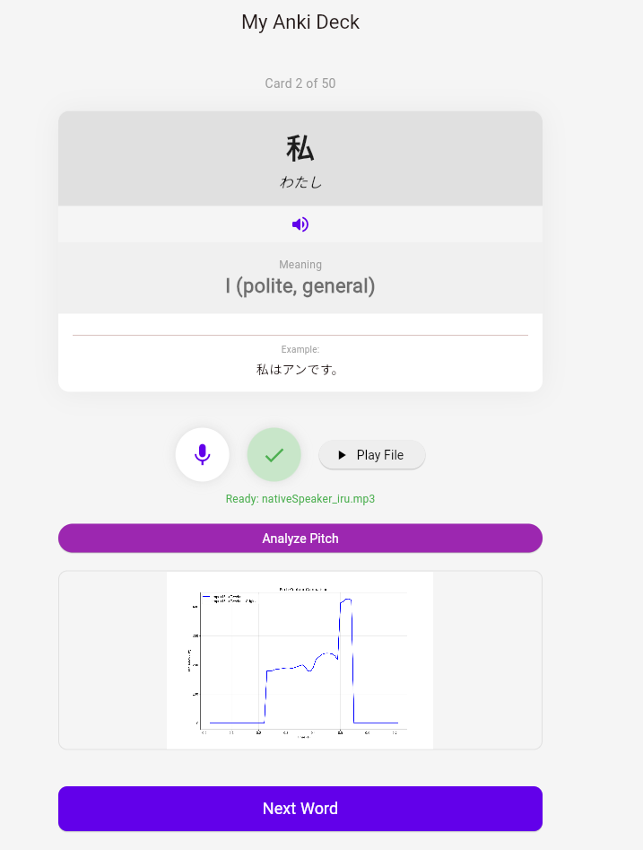

References

Software and libraries used

- Flutter SDK (UI framework)
- Flask / Flask-CORS (API + cross-origin support)
- Parselmouth (Praat integration)
- Matplotlib (graphing)
- Pydub + FFmpeg (audio conversion)
- SpeechRecognition (speech-to-text wrapper)
- Google Speech Recognition (via SpeechRecognition backend)
- pykakasi (Japanese → romaji conversion)

Links
- [1] Render https://render.com/

- [2] Anki connect, https://ankiweb.net/shared/info/2055492159

- [3] current anki deck used by project https://ankiweb.net/shared/info/1196762551

